Exercise

Question 1Sans MS

Lets download Youtube, myspace, Google and Yahoo1 logos. Implement a page as shown below using the downloaded images. For the text in this page, you are required to make use of the font 'Comic Sans MS' at a size of 48px and the color navy.



Mark Allocation
Correct use of tags | [2]
Font size changed | [1]
Font changed to Comic Sans | [1]
Font colour changed to navy | [1]
Images added | [2]
Displays correctly | [3]
Total | [10]
Question 2
Implement a page exactly as shown below:

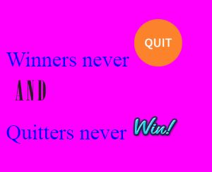
Use the images provided to you in the Question2 folder. For the text in this page you are required to make use of the font ‘Times New Roman‘ at a size of 30px and the color ‘blue’.
Mark Allocation
Criteria | Marks
Correct use of tags | 2
Font size changed | 1
Font changed to Times New Roman | 1
Font colour changed to ‘blue’ | 1
Images added | 2
Displays correctly | 2
Images resized | 1
Total: | 10

Question 3
Implement the webpage as shown below:
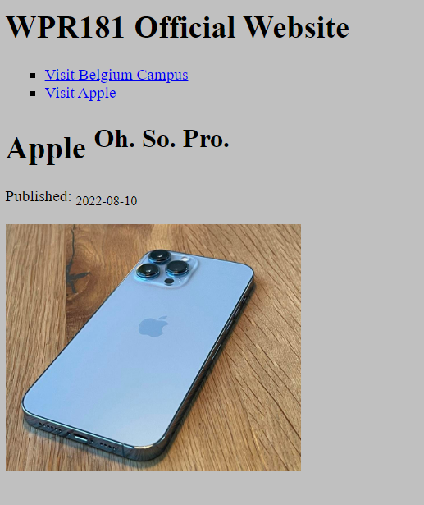
For the image, make sure you utilize absolute url:
https://imageio.forbes.com/specials-images/imageserve/6148e5c7b85bfa189955ed22/0x0.jpg?format=jpg&width=1200

Question 4
The following is a web server file structure of a website mystore.com:
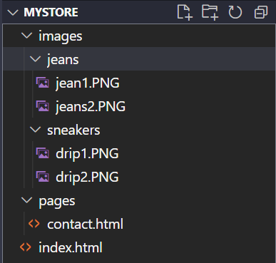
- Write down the html code for the anchor element that will display the drip1.PNG file on the index.html home page. Make sure the width of image to 30% and height is set to 40%. Use the style attribute to achieve this.

- Assume the following link is displayed on the index.html file.

Write down the html code for the anchor element of the above hyperlink. Use relative URL to connect to the contact.html page.

- State which one is root folder.

- Assume the following is a list of contact numbers for two branches of the store (Pretoria and Joburg) on the contact page:

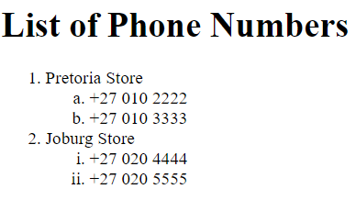

Write down the html code for displaying the above list.

